SWOT Analysis for OS Upgrades

By Laiken Knights

Table of Contents

Realistic Options: 3

Option 1 3

Option 2 3

Option 3 3

SWOT Analysis: 4

Strengths 4

Weaknesses 4

Opportunities 4

Threats 4

Bibliography 5

# Realistic Options:

## Option 1

Windows 7 is one possible option for the operating system of choice for the company. It is seasoned enough to be a safe operating system to use with support already set up. While its mainstream support ended on January 13, 2015 its extended support is set to last until 2020. The price of licensing can be found as low as $50 from online sources. The system requirements for windows 7 are as bellow:

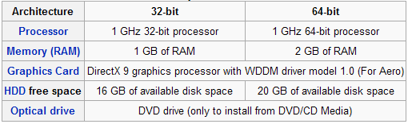

## 

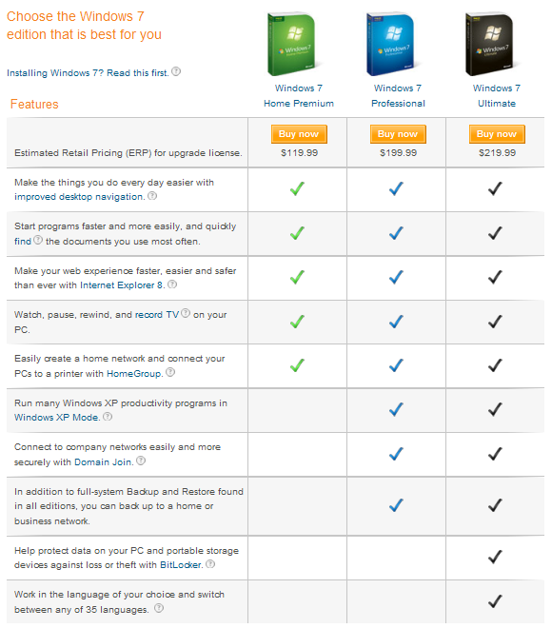There are three different versions of windows 7 that you could use with a rundown of helpful information for each:

## Option 2

Windows 8.1 is another possible option for the operating system of choice as it has similar advantages to windows 7 in that it is established enough to have proper support both by Microsoft and the users in that enough people use the system. The mainstream support for windows 8.1 is set to last until January 9th, 2018 and its extended support will last until January of 2023. Windows 8.1 is also very tablet friendly as its earlier release (windows 8), was criticized for being overly tablet friendly. The system specifications for windows 8.1 are:

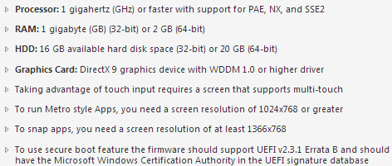

## 

The licensing cost of windows 8.1 can be a bit more costly ranging at $144 as it is still a recently new operating system and thus the cost will be higher.

## Option 3

Windows 10 is the last operating system I will recommend and it is the newest of the bunch. Its support will last the longest as its mainstream support will last until October 12th, 2021 and its extended support will last all the way until 2026.

# SWOT Analysis:

## Strengths

## Weaknesses

## Opportunities

## Threats

# Bibliography

* Windows 7. (2017, May 04). Retrieved May 04, 2017, from https://en.wikipedia.org/wiki/Windows_7
* Networking, Computers/Tablets, Operating Systems, and Details Media. "Windows 7 Professional SP1 32/64 Bit |Full Retail License And Installation Media | Ebay". *eBay*. N.p., 2017. Web. 4 May 2017.
* *Windows 7 System Requirements*. 2017. https://chetangole.com/blog/2009/10/finally-windows-7-is-here/. 4 May 2017.
* "Windows 8.1". *En.wikipedia.org*. N.p., 2017. Web. 4 May 2017.